#
# 20191219
# How to show with colors ESC symbosl, exists in text file.

[support@centos work]$ less -R /tmp/20191218-1719.postgresql.ssh.log.txt
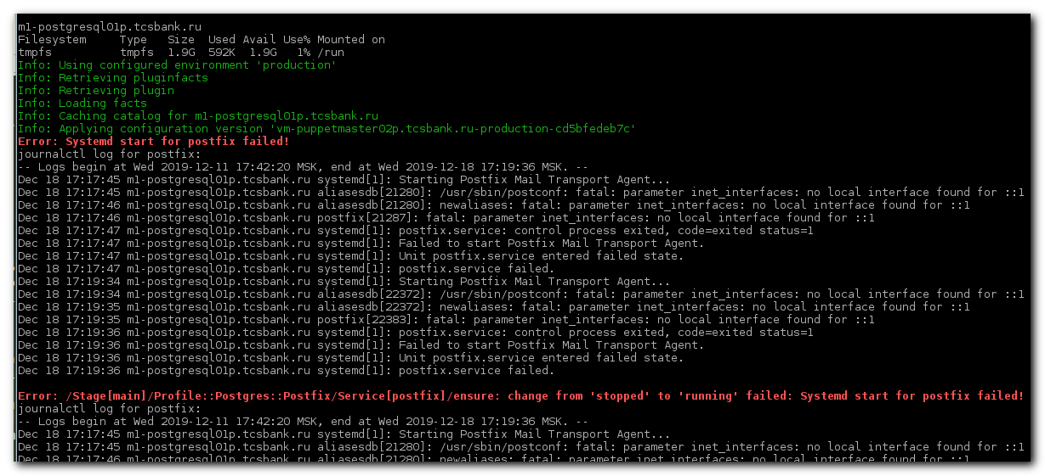

[support@centos work]$ less /tmp/20191218-1719.postgresql.ssh.log.txt
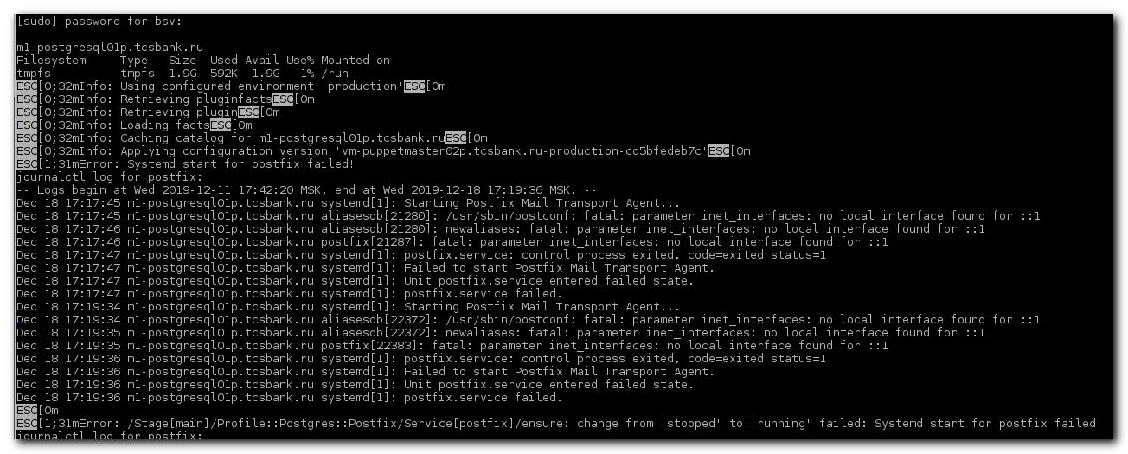

To remove escape special characters from output, I had use ansifilter.
Instead terminal view was corrupted and show unappropriate symbols.
[root@m1-afs-prod ~]# systool -c fc_host -v host5 | ansifilter
Class = "fc_host"

Class Device = "host5"
Class Device path = "/sys/devices/pci0000:20/0000:20:02.2/0000:24:00.7/host5/fc_host/host5"
dev_loss_tmo = "64"
fabric_name = "0xffffffff"
issue_lip = <store method only>
max_npiv_vports = "63"
node_name = "0x20002c27d753b1f7"
npiv_vports_inuse = "0"
port_id = "0x000000"
port_name = "0x21002c27d753b1f7"
port_state = "Online"
port_type = "Unknown"
speed = "unknown"
supported_classes = "Class 3"
supported_speeds = "10 Gbit"
symbolic_name = "CN1000Q FW:v4.12.11 DVR:v8.03.07.05.06.2-k"
system_hostname = ""
tgtid_bind_type = "wwpn (World Wide Port Name)"
uevent =
vport_create = <store method only>
vport_delete = <store method only>

Device = "host5"
Device path = "/sys/devices/pci0000:20/0000:20:02.2/0000:24:00.7/host5"
dcbx_tlv = ""
fw_dump =
nvram = "ISP "
optrom =
optrom_ctl = <store method only>
reset = <store method only>
sfp =
uevent = "DEVTYPE=scsi_host"
vpd = "�;"
xgmac_stats =

[root@m1-afs-prod ~]#

